**DAILY ONLINE ACTIVITIES SUMMARY**

|  |  |  |  |  |  |  |  |
| --- | --- | --- | --- | --- | --- | --- | --- |
| **Date:** | **24-06-2020** | | | | **Name:** | **B.A.SOHANKUMAR** | |
| **Sem & Sec** | **4TH SEM A** | | | | **USN:** | **4AL18CS013** | |
| **Online Test Summary** | | | | | | | |
| **Subject** | | **----** | | | | | |
| **Max. Marks** | | **----** | | **Score** | | **----** | |
| **Certification Course Summary** | | | | | | | |
| **Course** | **CLOUD COMPUTING WITH AWS** | | | | | | |
| **Certificate Provider** | | | **GLA** | **Duration** | | | **12 HOURS** |
| **Coding Challenges** | | | | | | | |
| **Problem Statement: Write a java program to find the length of linked list.** | | | | | | | |
| **Status:EXECUTED** | | | | | | | |
| **Uploaded the report in Github** | | | | **YES** | | | |
| **If yes Repository name** | | | | **LOCKDOWN CODING** | | | |
| **Uploaded the report in slack** | | | | **YES** | | | |

**CERTIFICATION COURSE DETAILS:**

Course: Cloud computing with aws

Completed modules today are Module 21-Web application firewall,CloudComputing_ EC2 _ Multi AZ Deployment _ Load Balancing,CloudComputing _ EC2 Autoscaling _ Shell Scripting with CLI,CloudComputing_Storage _Volumes,Using High level commands with the AWS CLI and successfully completed the course.

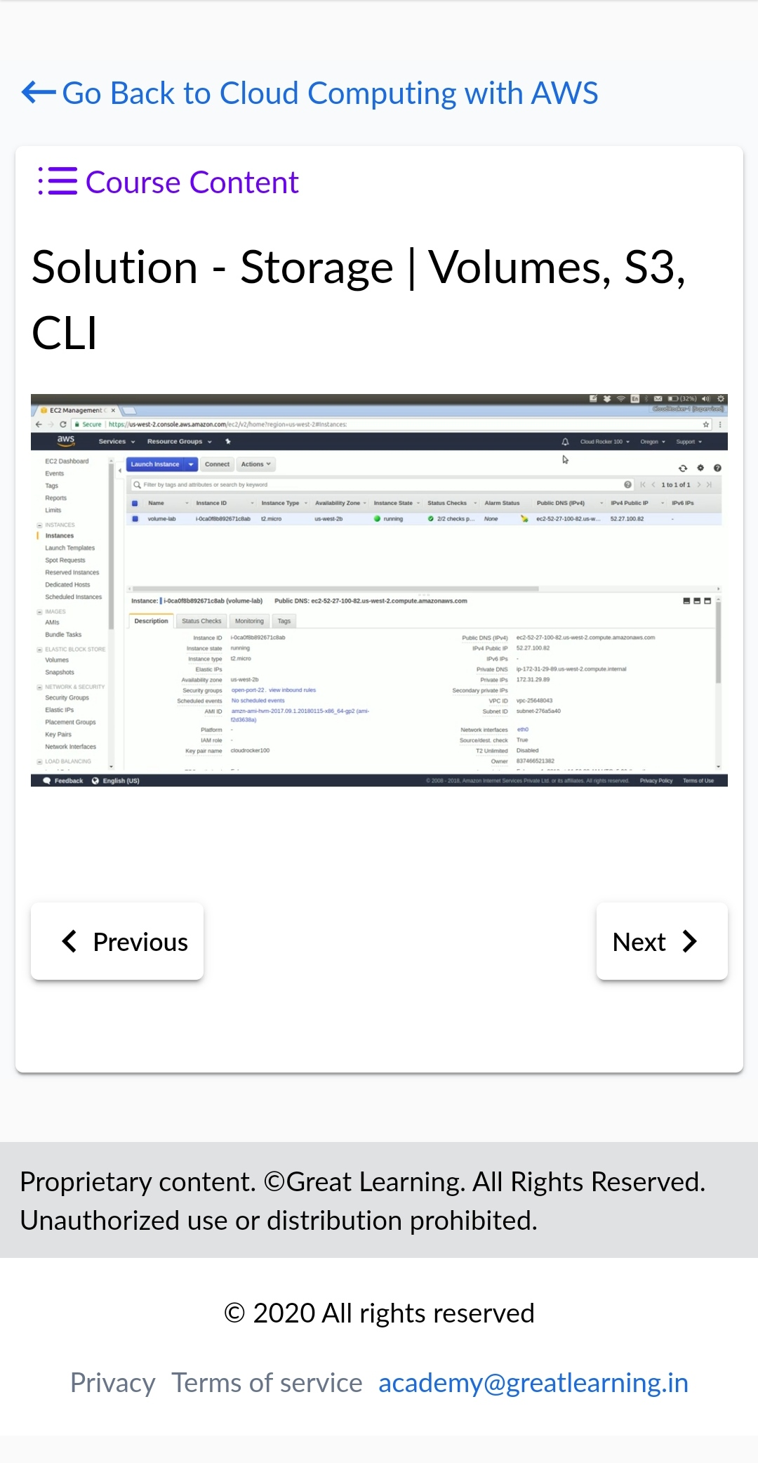 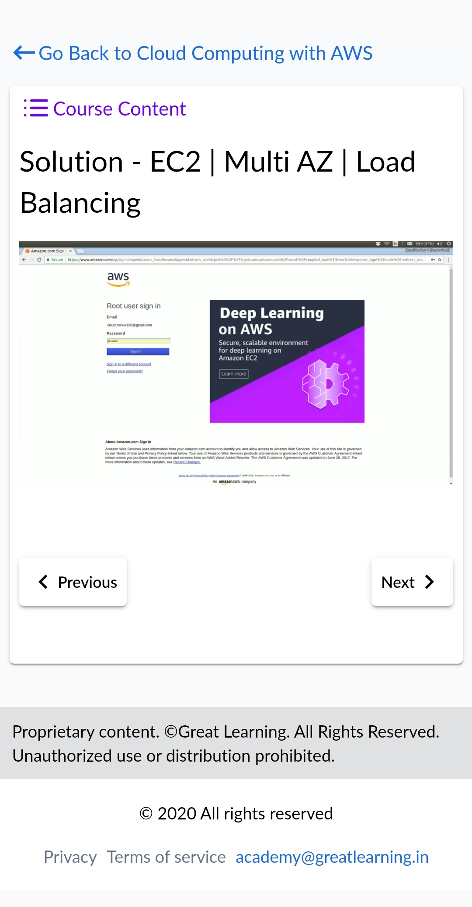

**CODING CHALLENGES DETAILS:**

1.Write a java program to find length of linkedlist.

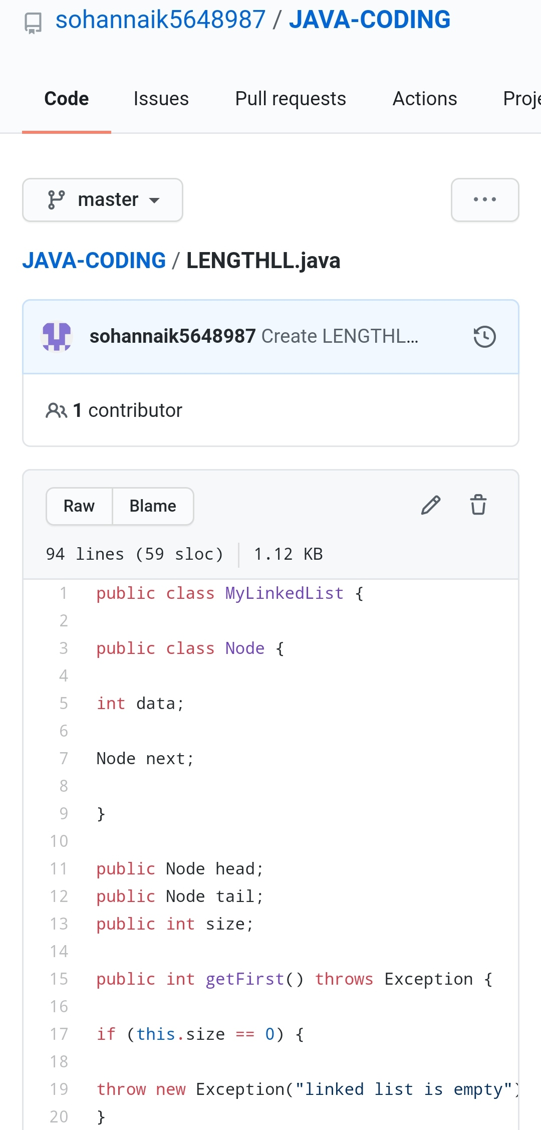

REPOSITORY LINK:https://github.com/sohannaik5648987/JAVA-CODING